Minimum Spanning Tree (MST) for Optimizing Pollution Monitoring Networks
Aaesha Alteneiji, Kulsum Ameen, Ahuod Albalooshi, Ghalya Almesafri, Isam Al Jawarneh
Department of Computer Science, University of Sharjah, P.O.Box 454535 Sharjah, United Arab Emirates
U24102490@sharjah.ac.ae, U24200613@sharjah.ac.ae, U24105514@sharjah.ac.ae,
U24200486@sharjah.ac.ae, ijawarneh@sharjah.ac.ae

Abstract—Air pollution monitoring is critical for human health. The deployment of a dense sensor network requires high costs, and is challenging to install and maintain, as the realworld pollution datasets are often large and complex. This paper provides a framework for exploring and analyzing geo-referenced air quality data using geohash grouping, clustering methods (DBSCAN) and the Minimum Spanning Tree (MST) algorithm (Kruskal’s method). In addition, it demonstrates how to simplify dense environmental data and find optimal sensor placements to derive valuable trends and insights. This study illustrates how MST structuring, with effective clustering, can improve the analysis and efficiency of pollution monitoring networks. The paper provides an practical method for researchers working with complex environmental data.
Index Terms—Minimum Spanning Tree (MST), Kruskal’s Algorithm, Pollution Monitoring, Clustering Algorithms.

INTRODUCTION
Air pollution is the most discussed issue at all times. According to the World Health Organization (WHO), exposure to contaminated air has led to an estimated 7 million premature deaths each year, mainly due to cardiovascular diseases, respiratory illnesses, and lung cancer [1]. Despite this recognized importance, the implementation of air quality monitoring system remains limited because of its deployment and maintenance of sensor networks requires high budget and is of high complexity.
This study emphasizes the limitations that surround air quality monitoring systems by applying data-driven techniques to optimize pollution monitoring networks. By using the air quality dataset from 121 different locations in Chicago, collected through a sensor network deployed since July 2021. The objective is to establish a framework that enhances the connection and efficiency of sensors while extracting meaningful environmental insights. The parameters includes extensive spatial and temporal air quality data, such as readings for PM₂.5, O₃ (ozone) , NO₂ (nitrogen dioxide), and CO (carbon monoxide), simultaneously with metadata such as temperature, humidity, battery health.
The challenges include the massive volume and complexity of this geo-referenced data. By utilizing clustering methods (e.g., K-means, dbscan) along with Minimum Spanning Tree (MST) algorithms to decrease data redundancy and identify optimal sensor placements. This dual approach supports efficient network design by capturing spatial patterns and connectivity while maintaining the accuracy of the original dataset. By implementing this methodology on a real-world urban dataset, this study contributes a practical solution for environmental monitoring, helping city planners, researchers, and public health organizations in deploying smarter and more efficient air quality surveillance systems.

RELATED LITERATURE
This study [2] presents a detailed examination of the relationships between particulate matter (PM2.5) and (PM10), nitrogen dioxide (NO2), and ground level ozone (O3) in terms of their concentrations in three cities influenced by meteorological conditions. The correlation between PM2.5 and NO2 is discovered to be negative between temperature and both NO2 and PM concentrations including PM2.5 which suggests that higher temperatures are associated with lower concentrations of NO2 and PM2.5. It is observed that O3 concentrations are positively correlated with temperature with correlation values of 0.51, 0.74, and 0.46 in Krakow, Milan, and Paris, respectively reflecting that as temperatures rise, O3 levels also increase. Moreover, PM2.5 tends to have higher concentrations during cooler months and lower temperatures in hotter months. The discussion of temporal variations of NO2, PM10, and PM2.5 is vital and in this paper, it is found that concentrations are higher during winter and nighttime, while O3 peakes during summer and midday. Additionally, O3 concentrations were found to be higher on weekends due to decreased anthropogenic emissions, which can also affect the levels of NO2 and PM2.5. It is necessary to understand these relationships for developing air quality management strategies.
The Dijkstra algorithm is the best approach to analyzing the shortest path, with the existing work that improves this algorithm. This research study mainly focuses on how to compute the best path for optimization using the A* algorithm under a mobile gas environment [3]. The Dijkstra algorithm is used to find out the shortest paths through a road network. A* algorithm is a learning technique used to optimize routing decisions based on various factors [4]. A* algorithm was first proposed by Peter Hart, Nils Nilsson, and Raphael. Unlike the Dijkstra algorithm, which does not know how far the final state, the A* algorithm has a vertex from start to current and from current to the desired state. While it is not a breadthfirst search, the A* algorithm is a heuristic search method commonly used to find the shortest path [3]. To get the best path from source to destination we used a specific function of A* algorithm which is defined as:
f(j) = g(j)+ h(j) (1)
Where g (n) is the path cost from the starting state to vertex n, and h (n) is the approximate cost of the shortest path from vertex (n) to the desired state, so we have f (n) = the approximate cost of the best path that continues from vertex (n) to the desired goal [5].
The Minimum Spanning Tree (MST) algorithm and clustering have been extensively used to enhance sensor networks for pollution monitoring. These methods have also been applied in various fields, such as environmental monitoring and vehicular ad hoc networks (VANETs). VANET Cluster-on-Demand MST Prim Algorithm, a paper presented by J. J. Kponyo et al., uses Prim’s algorithm to form vehicle clusters based on GPS data. It focuses on minimizing cluster sizes to ensure Quality of Service (QoS) by limiting the number of vehicles per cluster and keeping them within a specified distance from the cluster head. This approach provides excellent interaction, especially in environments where maintaining reliable data flow is crucial
[6].
In conjunction with MST and clustering techniques, the development in spatial encoding—especially Geohash encoding—that is proven to be effective in managing largescale geospatial data like environmental monitoring or remote sensing. The way it works is that geohash converts geographic coordinates into string-based that is grid-like spatial decompositions, that leads to fast filtering, spatial queries, and comparison. Moreover, locations that have a shared Geohash prefixes, do as well have same spatial cells, and the spatial resolution is directly proportional to the length of shared prefix. Therefore, this property leads to having scalable, highresolution spatial indexing which is useful in air quality data analysis. As proposed by Alsalama et al. in [7]. For instance, systems such as GeoMapComp have utilized geohash to vectorize and compare regional geo-maps using statistical similarity measures that support efficient representation of environmental data.
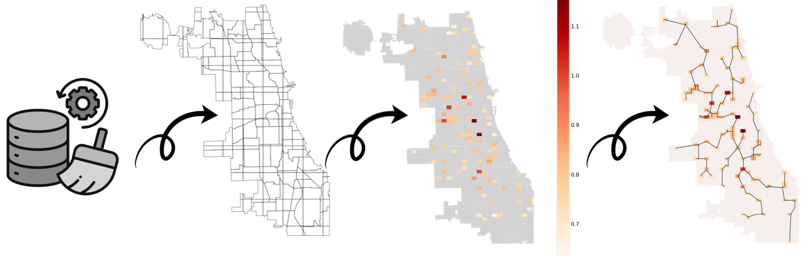
Fig. 1. The process flows for analyzing air quality data (Collect Data, Geocoding, Clustering, and MST).

METHODOLOGY AND SYSTEM ARCHITECTURE
This section explains the methodology implemented to analyze the spatial pollution data and generate effective minimum spanning tree path for optimizing pollution monitoring networks. As shown in Fig. 1.
It is essential to collect a large data set during different timestamps and from diverse resources. A large data set has been collected, analyzed based on the available environmental and functional variables to select the best pollution columns, filtered to remove the missing values and outliers, grouped through multiple different criteria, sampled and clustered to generate the best MST path, and enable efficient sensor placement. The reason behind each process is explained in the following subsections.

A. Algorithms Overview
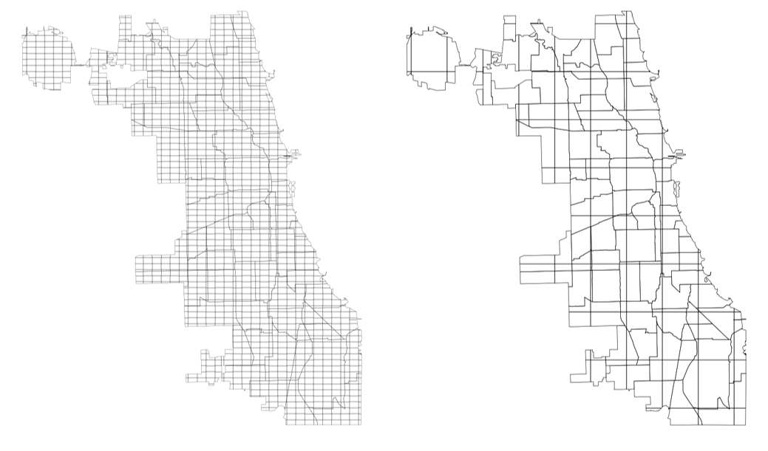
Fig. 2. Chicago geohash grids at 6 precision (left) and 5 precision (right), showing different levels of spatial resolution [20]
- Geohash Encoding: Geohash, introduced in 2008 by Gustavo Niemeyer, is simply an approach to encode the geographic coordinates (latitude and longitude) into a short numerical string to aggregate nearby points into grid-like regions [8]. Geohash precision varies based on the encoded characters, the more characters there are, the higher spatial resolution and the smaller area represented by the grid as shown in Fig. 2. [9]. This method is effective in studies involving a proximate spatial analysis as it simplifies and speeds up the data querying process.
- Sampling: Sampling is an essential part of data science, as it involves the process of selecting a subset of observation from population or large dataset. Samples enable scientists to reduce the data volume while preserving the population characteristics, ensure proper representation, minimize redundancy and optimize resources. Some of the important methods of sampling are sampling with replacement, when the sampled individual is selected from array and it is possible to select the same sample again, the second is sampling without replacement, when the sampled individual is not in returned to the population until all required individuals are selected [10], which will be used in this study to select a proportional random sample from the population to allow efficient clustering process.
- K-Means algorithm: The K-Means clustering algorithm is a partitioning clustering method that separates data into K number of groups. The K-means algorithm is particularly effective at rapidly and efficiently clustering large amounts of data.
K-Means clustering algorithm is an unsupervised clustering algorithm in which the centroids are initialized with any number. The K-Means algorithm is very sensitive to the starting vertex. It is used to analyze air pollution to improve both the correctness and proficiency of the clustering process [12].
The goal is to find a set of k points in R^{d}, called centers, that minimizes the mean squared distance between each data point and its closest center, given a collection of n data points in real d-dimensional space, R^{d}, and an integer k. This clustering technique falls under variance-based clustering, and the metric is often called squared-error distortion [14].
- DBSCAN algorithm: DBSCAN was invented by Ester et al. in 1996. A clustering algorithm that clusters points based on whether they fall into a predetermined neighborhood with other points. This method can cluster points with more complicated shapes and is not sensitive to initial values. This algorithm does not require clustering for all points, allowing those points that do not fall into a particular cluster be defined as noise [13].
DBSCAN initiates the identification of a cluster with an arbitrary point p and thereafter retrieves all points that are density-reachable from p concerning Eps and MinPts. If p is a core point, this procedure produces a cluster with respect to Eps and MinPts. If p is a border point, no points are densityreachable from p, and DBSCAN proceeds to the subsequent point in the database. Due to the utilization of global values for Eps and MinPts, DBSCAN may merge two clusters into a single cluster, if clusters of different densities are located near each other [15]. As demonstrated by Aljawarneh et al. [21] clustering algorithm, particularly Density-Based Spatial Clustering of Applications with Noise (DBSCAN), that is important for successfully grouping users based on their historical records and location data. Incorporating such clustering methods could optimize participant selection based on geospatial data.
- Dijkstra’s algorithm : ”The Dijkstra approach determines the shortest path in weighted graphs (networks) by iteratively identifying the node with the smallest distance and updating its adjacent nodes [16]. This algorithm operates by selecting the node with the smallest estimated distance using a greedy method. As a result, the neighboring nodes are updated, progressively refining the path to the destination [18]. Dijkstra’s algorithm is particularly effective for networks with non-negative edge weights to ensure the shortest path is always found. Its time complexity of O((n + m) log n) makes it efficient for graphs with relatively small to moderate numbers of nodes and edges [18].
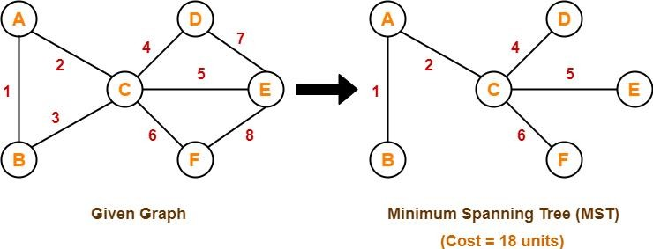
Fig. 3. Minimum Spanning Tree using Kruskal’s Algorithm
- Kruskal’s algorithm : Kruskal’s algorithm, introduced in 1956 by Joseph Kruskal is used to compute the minimum spanning tree (MST) based on the weighted path without cycles. Kruskal’s algorithm starts by calculating the weight between all the possible vertices pairs. After that, the weighted edges are sorted in ascending order, and the shortest edge is added to the execution query, then the second shortest edge is selected and evaluated if it can be added to the MST or it will perform a cycle, then the process is repeated until all vertices are connected without cycles as shown in Fig. 3. [11]. The algorithm is effective for geospatial optimization tasks and network designs. In this study, the minimum spanning tree is used to find the best path to connect all sensors based on the spatial distance and the weighted pollutions average for optimizing pollution monitoring networks.

B. Data Processing
- Collecting and cleaning data : For testing the clustering and minimum spanning tree algorithms, two publicly available geospatial datasets were chosen. The first dataset contains air quality data collected in 121 locations in Chicago, Illinois, USA, using low-cost air quality sensing networks. The data contains the device id, city, location name, geospatial coordinates, reading time, pollution levels (PM2.5, calibratedPM2.5, calibratedO3, calibratedNO2, CO), environmental and functional variables (temperature, humidity, battery level and percentage, cell signal), the data was collected from 19 files, containing over 2.4 million readings starting from July 2021. The second is Geojson file that contains the boundaries of Chicago city, used to plot the map.
In this part, multiple data preprocessing and validation steps were implemented to ensure the suitability and reliability for analysis. These included comparing the five different pollution readings by time, selecting the best and reliable columns, filtering missing data and outliers.
Then, an analysis has been conducted to examine the impact of the environmental and functional variables on the selected pollution data during the available reading periods. After analyzing the effects, these columns were removed to reduce the data volume and improve computational efficiency. The selected pollution data, as shown in Fig. 4. was normalized to check the effect of the total pollution data. In addition, geohash code was generated to the cleaned data for further analysis.
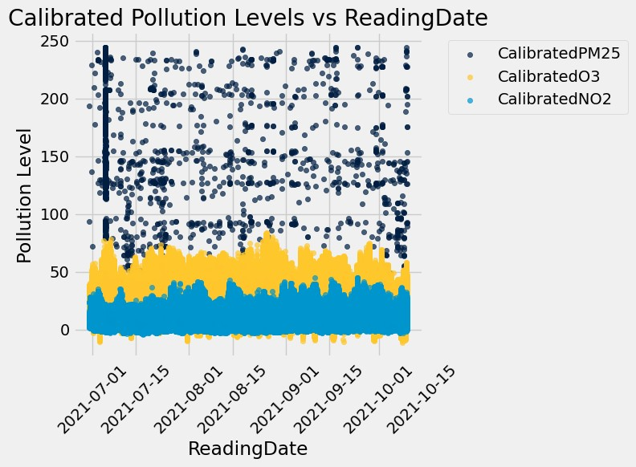
Fig. 4. Scatter plot showing the calibrated pollution levels (PM2.5, O3, and NO2) over time.
- Grouping and sampling data : Multiple grouping strategies were applied to reduce the data volume and examine the effect on the minimum spanning tree. The data was grouped by device ID and geohash codes. Moreover, a random sample data without replacement with the same distribution of the different locations in the population was generated.
- Clustering data : There are mainly two reasons why we chose DBSCAN over K-Means for this pollution-based data.
First, K-Means is generally unsuitable for pollution sensors because it assumes spherical clusters and requires a predefined number of clusters. In contrast, DBSCAN is suitable for spatial and environmental data. DBSCAN identifies clusters based on the density of data and does not require predefining the number of clusters. This is ideal for pollution data, where areas of concern are unpredictable in urban areas.
Secondly, K-Means assigns each point to a cluster, even the outliers, which can give errors in the result. But DBSCAN removes the outliers by giving them a -1 value and takes the rest of the points as clusters. Furthermore, DBSCAN performed effectively with geographic coordinates, it can capture irregular shapes, which is extremely useful in pollution-based data.
- Minimum Spanning Tree : The Minimum Spanning Tree (MST) is a selection of edges in a connected weighted graph that links all vertices with the lowest possible total edge weight while avoiding cycles. Kruskal’s algorithm, a greedy technique, constructs the MST by ordering the edges in increasing weight and adding the smallest edges that do not create a cycle [19]. Applying this method to our study on grouped-only and grouped-and-clustered data. The MST for monitoring pollution networks heavily relies on pollution levels, such as PM2.5, and Kruskal’s algorithm was selected to meet the required specifications. Kruskal’s algorithm effectively identifies the best routes for sensor placement and data transmission by using pollution data as weights. For largescale pollution monitoring networks, this approach ensures that the monitoring network is both cost-effective and efficient.
- Sensors Optimizing suggestion : In this subsection, the grouped data be geohash was analyzed based on the number of available devices and pollution records. Then, based on the average pollution level for each number of sensors, a suggestion to increase / decrease / maintain the number of sensors in each geohash was performed.
- Accuracy Calculations : To measure accuracy, as demonstrated in [17] in which the average total running time and clustering accuracy are used as performance metrics during empirical evaluations of their algorithm where the study evaluation includes comparisons against k-means and other MST algorithms under various conditions. As a result, this paper refers to the same metrics for assessing the efficiency of the algorithm.

RESULTS AND DISCUSSION
Atmospheric air quality is analyzed and explored using hyperlocal air quality dataset collected from sensors spread in different areas in the city of Chicago. The dataset includes calibrated and uncalibrated pollutant values, concurrently with meteorological and device performance parameters. The aim is to understand the behavior, structure, and quality of the parameters that supports the optimized network design developed using the technique of Minimum Spanning Tree (MST).

A. Preprocessing
An initial check to the 2.46 million data records was implemented, in which it is evident that the uncalibrated pollutant values (PM2.5) have unreasonable outliers, unlike calibrated readings (CalibratedPM2.5, CalibratedO3, and CalibratedNO2) that showed reliable data but with missing 34,277 entries for each one of them. The way it is done by filtering the data to return the count of missing values in each column for visualizations and trend analyses.
The missing data revealed significant gaps in pollutantrelated fields:
- CalibratedPM2.5: 34,277 records, 1.4% missing
- CalibratedO3: 34,277 records, 1.4% missing
- CalibratedNO2: 34,277 records, 1.4% missing
The missing values that were shown across all three calibrated pollutant columns in identical proportions suggests that it is either due to simultaneous sensor outages or centralized calibration pipeline issues that caused outliers to the actual readings. The empty values were excluded from analysis to ensure reliability of visualization and statistical observation. This filtration process has removed the outliers in PM2.5 column.
The further analysis has been applied to the calibrated pollutants, Scatter plots were used to view the behavior of calibrated pollutant concentrations over time and the environmental variables:
- Pollution vs Reading Date: According to the scatter plot of CalibratedPM2.5, CalibratedO3, and CalibratedNO2, there are minor variations over time but no clear increasing or decreasing trend. The temporal stability of PM2.5 and NO2 indicates that the time does not significantly impact the behavior of pollution levels during the collected period (July 2021 - October 2021).
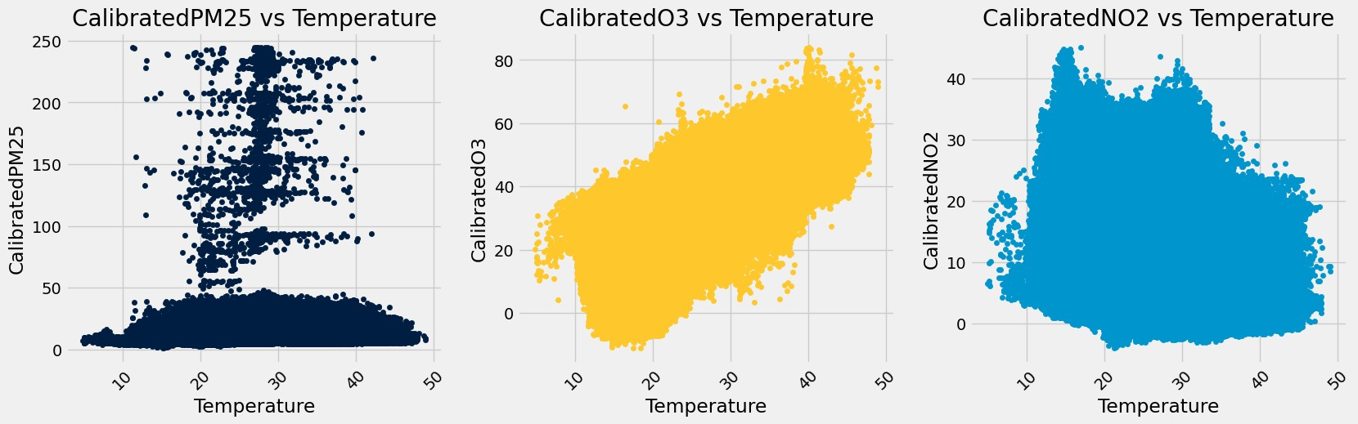
Fig. 5. The relationship between calibrated pollution readings (PM2.5, O3, and NO2) and temperature in Chicago.
- Pollution vs Temperature: It is evident that CalibratedO3 shows a clear positive correlation with temperature when compared to PM2.5 and NO2 it does not show that there is a correlation with the temperature which means that PM2.5 and NO2 are driven by pollutant sources rather than ambient temperature according to Fig. 5.
- Pollution vs Humidity: CalibratedO3 demonstrates a negative correlation with humidity. However, PM2.5 and NO2 remain unaffected indicating that they are constant despite humidity changes. The MST should be able to recognize its connectivity as response to humidity changes, resulting in optimized sensor placement in the areas that are influenced by moisture levels, which improves the accuracy of environmental monitoring and pollutant detection.
- Pollution vs Percent Battery: The measurement of pollutants remains stable across battery levels, which confirms that sensor readings are independent of power fluctuations. The reason for this behavior lies within the MST algorithm, which focuses on spatial placement instead of battery lifespan which ensures the reliability of the readings during network optimization regardless of battery level.
- Pollution vs Cell Signals: It is notable that there is no correlation between cell signal strength and pollutant concentrations. Despite this, maintaining strong network connectivity is crucial for real-time MST monitoring. As a result, the MST model should prioritize areas in which there is stable connectivity. This has an influence on having uninterrupted data transmission in the pollution monitoring network.

B. Processing
Based on the earlier analysis, the device id, location, time and calibrated pollution columns were selected for further analysis. following this selection, a 6-character precision geohash codes were generated to support the spatial grouping, and each calibrated pollutant column was normalized to a [0, 1] scale using the minimum and maximum values to ensure a consistent comparison between the columns, to calculate the total sum of the normalized columns for the study.
Five different grouping strategies were applied to the dataset, each varying in spatial, sensor or clustering aggregation logic. For each of these aggregations, a minimum spanning tree was generated to analyze the spatial connectivity based on the pollution weight.
The first strategy was to group the data by device id, calculate the count of the readings, and the average value for location and pollution columns. The aggregation showed that 121 different sensors were used for this analysis. It was observed that certain sensors contributed many readings (approximately 28 thousand), while a few had between 5 and 10 readings only. MST logic was then applied to this group using the location and total normalized pollution level, and a path weighted 3.44 was generated.
The second strategy was to use the same sensor grouping and generate cluster ID using the DBSCAN method based on the distance with epsilon of 0.3 and the total normalized pollution level. The centroid points were then generated based on the average latitude, longitude values, 88 different vertices were generated. The same MST logic reapplied for this grouping and the weighted path was reduced to 3.14, which indicates the benefits of using clustering to group the data, especially when the monitoring networks do not require a
direct connection between each sensor.
The third strategy was to group the data by geohash code, calculate the number of sensors in each geohash, the reading counts and the average for the remaining columns. Compared to the sensor grouping, the aggregation showed that the sensors were placed in 106 different geohash grids. The total number of the measured records also increased, with some areas having around 78 thousand readings. The grouping also showed that the number of sensors in each geohash ranged from 1 to 3, although most areas had only one sensor. The MST method was also applied in the same way, and a path with a total weight of 3.33 was generated, which is slightly better than grouping by sensors only, but higher than the clustered sensor data.
The fourth strategy was to use the geohash grouped data and implement the DBSCAN method with the same epsilon value. The clustering and centroid method generated 83 different vertices. The MST logic then produced a path weighted 3.10, which indicates that grouping by geohash then clustering the data produced a better path compared to the above strategies as illustrated in Fig. 6.
The fifth strategy was to sample 20% of the data, with stratified sampling distribution method based on the reading location. Due to the large volume of ungrouped data, applying
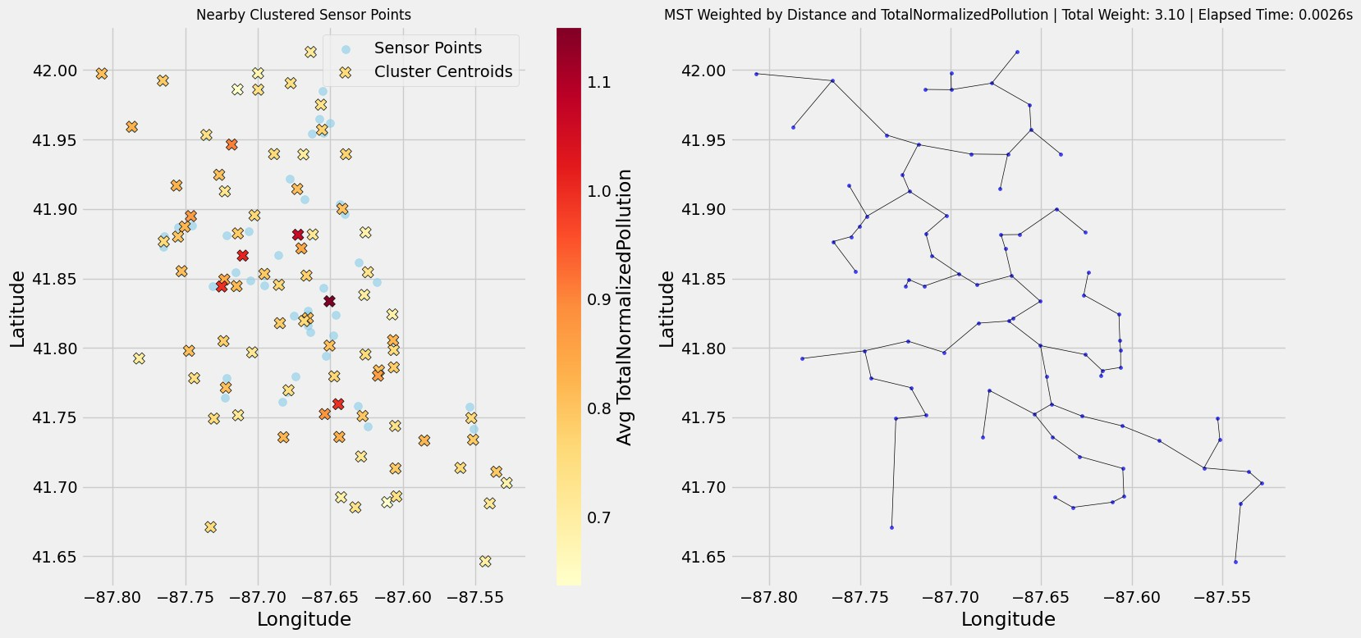
Fig. 6. Visualization of clustered sensor points and the Minimum Spanning Tree (MST) for Chicago, with sensor locations color-coded by average normalized pollution levels.
the clustering based on the pollution level, has generated multiple nearby points with different pollution concentrations. Due to the high number of vertices and pollution levels, the MST showed a higher weighted path compared to the above strategies with value of 4.34.
The outcome of this analysis the fourth strategy—grouping the data by geohash, to get the average pollution levels, followed by clustering them, yielded the best average path that will work over the year, the weight might show a lower value compared to the highest pollutant period or higher value during the clean or low pollution period.
Following the best minimum spanning tree analysis, the number of sensors in each geohash compared to the pollution levels and number of observed records were analyzed, to optimize a change to the number of sensors. The sensors range for each area was considered based on the available records which is between 1 and 3 sensors in each geohash. A recommendation to collect additional data when the number of available records in the selected areas was found to be fewer than 100, and to increase the number of sensors when the pollution level is greater than 65% and sensor count is below the maximum. For the sensors with less than 35% pollution level and where the number of sensors is maximum, it is suggested to reduce the number of sensors, and to maintain the current numbers for the remaining cases.
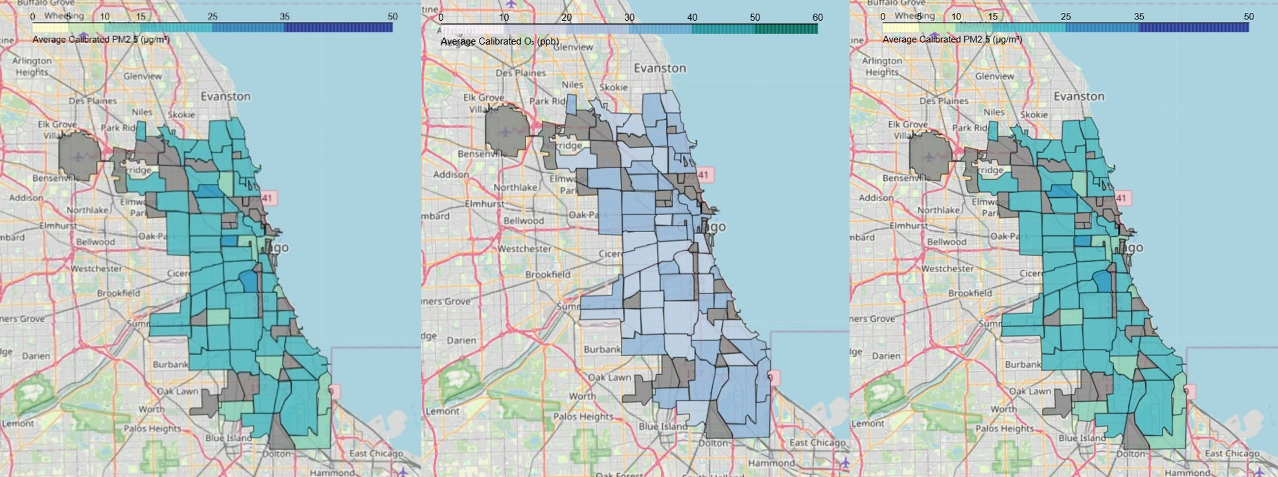
Fig. 7. These choropleth maps display the average concentrations of Calibrated PM2.5, O2, and NO2 across Chicago neighborhoods, highlighting spatial variations in air quality.
Fig. 7. illustrates the spatial distribution of air pollutants—Calibrated PM2.5, O3, and NO2 across Chicago neighborhoods. Each choropleth map visually represents the average concentration levels using color gradients, where darker shades indicate higher pollutant levels. This side-by-side comparison enables the clear identification of areas with elevated pollution, helping to uncover spatial patterns and inform localized environmental interventions. These maps were generated using spatial joins and Folium visualizations based on real sensor data. The neighborhood boundary GeoJSON was sourced from a public GitHub repository [22] , and the environmental sensor readings were taken from the dataset used in this project [23].

SUMMARY AND FUTURE WORK
This study focuses on analyzing spatial pollution data and optimizing monitoring networks through the minimum spanning tree algorithm based on the data collected from Chicago city. It was evident from the results that the best strategy to generate the shortest weighted path and optimize the monitoring networks—by reducing costs, eliminate redundancy path and improve scalability—is to aggregate the data by the geohash code to find the average total normalized pollution level, apply clustering using DBSCAN algorithm to consider the pollution levels at nearby points, including those across geohash boundaries, then finally generate the minimum spanning tree using Kruskal algorithm based on the shortest weighted pollution path. For a dual benefit of cost-efficient routing, we extended the study by providing suggestions to optimize the number of sensors in each area. This will contribute to smarter sensing strategies.
First, the plan is to integrate dynamic sensor data, which could allow MST to be used in real-time. Additionally, the A* algorithm will be implemented to optimize sensor routes for mobile monitoring. Other clustering methods will be explored for comparison, and an effort will also be made to find a way to use k-means for such data by utilizing the Elbow technique. Finally, an attempt will be made to expand the data from one city to multiple cities, which would help validate the model’s generalizability. Despite the valuable insights gained through this study, it still has limitations.
This study analyzed a representative portion of the original data and this happened because of computational and visualization constraints. If more data was covered, this would reveal more seasonal and spatial behaviors. Furthermore, the analysis did not include meteorological data—such as wind speed and solar radiation—which would influence pollutant distribution. The result is generalizable to other urban air quality networks in which the low-cost sensors increase flexibility; however, it increases challenges related to data quality. By preprocessing data and develop insights using optimization algorithms, cities can utilize smarter, and easy-to-implement adaptive sensor networks that will enhance public health.
ACKNOWLEDGMENT The authors used OpenAI’s ChatGPT to support in the code.

REFERENCES
- World Health Organization, “Health community calls for urgent action for clean air ahead of WHO conference,” World Health Organization, Jan. 27, 2025. [Online]. Available: https://www.who.int/news/item/2701-2025-health-community-calls-for-urgent-action-for-clean-air-aheadof-who-conference
- O. E. Rowland, “Comparative analysis of meteorological parameters and their relationship with NO₂, PM₁₀, PM_{2.5} and O₃ concentrations at selected urban air quality monitoring stations in Krakow, Paris, and Milan,” *Discov. Environ.*, vol. 2, p. 75, 2024. doi: 10.1007/s44274024-00060-2
- F. W. J. L. Gen Tian, “An improved best path methodology for mobile GIS based on A* algorithm,” in *Proc. 2nd Int. Conf. Artif. Intell., Manag. Sci. Electron. Commer. (AIMSEC)*, Dengleng, China, 2011.
- P. Muthuvel and R. C. Muthuvel, “Optimizing road networks: A graphbased analysis with path-finding and learning algorithms,” *Int. J. Intell. Transp. Syst. Res.*, vol. 23, no. 1, pp. 315–329, 2024.
- S. Russell and P. Norvig, *Artificial Intelligence: A Modern Approach*, 4th ed. Hoboken, NJ, USA: Pearson, 2020.
- J. J. Kponyo, E. Boakye, R. Osei, and A. M. Owusu, “VANET clusteron-demand MST Prim algorithm,” *IEEE Trans. Veh. Technol.*, vol. 62, no. 6, pp. 2902–2914, 2019.
- A. Alsalama, A. Kubba, M. Alsmirat, and I. M. A. Jawarneh, “A novel approximate computing method for efficient search in satellite remote sensing products,” in *Proc. 2024 Int. Conf. Multimedia Comput., Netw. Appl. (MCNA)*, Valencia, Spain, 2024, pp. 21–27, doi: 10.1109/MCNA63144.2024.10703889.
- I. M. A. Jawarneh, P. Bellavista, A. Corradi, L. Foschini, and R. Montanari, “Spatially representative online big data sampling for smart cities,” in *Proc. IEEE CAMAD*, Pisa, Italy, 2020, pp. 1–6.
- R. Moussalli, M. Srivatsa, and S. Asaad, “Fast and flexible conversion of geohash codes to and from latitude/longitude coordinates,” in *Proc. IEEE FCCM*, Vancouver, BC, Canada, 2015, pp. 179–186.
- D. Adhikari *et al.*, *Computational and Inferential Thinking: The Foundations of Data Science*. [Online]. Available: https://www.
inferentialthinking.com/
- P. B. Guttoski, M. S. Sunye, and F. Silva, “Kruskal’s algorithm for query tree optimization,” in *Proc. 11th Int. Database Eng. Appl. Symp. (IDEAS)*, Banff, AB, Canada, 2007, pp. 296–302.
- G. R. Kingsy, R. M. D. M. G. S., and B. N. R. K. Usha, “Air pollution analysis using enhanced K-means clustering algorithm for real-time sensor data,” in *Proc. IEEE TENCON*, Singapore, 2016.
- R. J. Actkinson and B. G., “Detecting plumes in mobile air quality monitoring time series with density-based spatial clustering of applications with noise,” *Atmos. Meas. Tech.*, vol. 16, no. 14, pp. 3547–3559, 2023.
- T. Kanungo, D. Mount, N. Netanyahu, C. Piatko, R. Silverman, and A. Wu, “An efficient k-means clustering algorithm: Analysis and implementation,” *IEEE Trans. Pattern Anal. Mach. Intell.*, vol. 24, no. 7, pp. 881–892, 2002.
- M. Ester, H.-P. Kriegel, J. Sander, and X. Xu, “A density-based algorithm for discovering clusters in large spatial databases with noise,” in *Proc. 2nd Int. Conf. Knowl. Discov. Data Min. (KDD)*, USA, 1996.
- K. Wei, Y. Gao, W. Zhang, and S. Lin, “A modified Dijkstra’s algorithm for solving the problem of finding the maximum load path,” in *Proc. IEEE Int. Conf. Inf. Comput. Technol.*, Guangzhou, China, 2019, pp. 978–1–7281–3323–2.
- X. Wang, X. Wang, and D. M. Wilkes, “A divide-and-conquer approach for minimum spanning tree-based clustering,” *IEEE Trans. Knowl. Data Eng.*, vol. 21, no. 7, pp. 945–958, Jul. 2009, doi: 10.1109/TKDE.2009.37.
- R. D. Gunawan, R. Napianto, R. I. Borman, and I. Hanifah, “Implementation of Dijkstra’s algorithm in determining the shortest path (case study: Specialist doctor search in Bandar Lampung),” *Int. J. Inf. Syst. Comput. Sci.*, 2019.
- A.-A. Mamun and S. Rajasekaran, “An efficient minimum spanning tree algorithm,” in *Proc. IEEE ISCC*, Messina, Italy, 2016, pp. 949–954, doi: 10.1109/ISCC.2016.7543862.
- I. M. Al Jawarneh, P. Bellavista, A. Corradi, L. Foschini and R. Montanari, ”Efficiently Integrating Mobility and Environment Data for
Climate Change Analytics,” 2021 IEEE 26th International Workshop on
Computer Aided Modeling and Design of Communication Links and Networks (CAMAD), Porto, Portugal, 2021, pp. 1-5, doi: 10.1109/CAMAD52502.2021.9617784.
- I. M. Aljawarneh, P. Bellavista, A. Corradi, R. Montanari, L. Foschini and A. Zanotti, ”Efficient spark-based framework for big geospatial data query processing and analysis,” 2017 IEEE Symposium on Computers and Communications (ISCC), Heraklion, Greece, 2017, pp. 851-856, doi: 10.1109/ISCC.2017.8024633.
- M. Black, ”Chicago Neighborhoods GeoJSON,” GitHub, [Online].
Available: https://github.com/blackmad/neighborhoods
- I. Aljawarneh, ”AQ data – Chicago Air Quality Dataset,” GitHub, [Online]. Available: https://github.com/IsamAljawarneh/datasets/tree/master/ data/Chicago/AQ data

